**Assignment (roll no. 67)**

1. What is the difference between truncate, delete, drop?

The DELETE command deletes one or more existing records from the table in the database.

The DELETE command performs slower than the DROP command and TRUNCATE command as it deletes one or more rows based on a specific condition.

DELETE FROM table_name WHERE condition;

The DROP Command drops the complete table from the database.

The DROP Command has faster performance than DELETE Command but not as compared to the Truncate Command because the DROP command deletes the table from the database after deleting the rows.

DROP TABLE table_name;

The TRUNCATE Command deletes all the rows from the existing table, leaving the row with the column names.

The TRUNCATE command works faster than the DROP command and DELETE command because it deletes all the records from the table without any condition.

TRUNCATE TABLE table_name;

2. What are alias in MySQL?

* SQL aliases are used to give a table, or a column in a table, a temporary name.
* Aliases are often used to make column names more readable.
* An alias only exists for the duration of that query.
* An alias is created with the AS keyword.

3. How do you display even rows of the any table?

**select t.rownumber, t.employee_id, t.first_name from (**

**select *, row_number() over(order by employee_id) as rownumber from employees) t**

**where t.rownumber % 2 =0;**

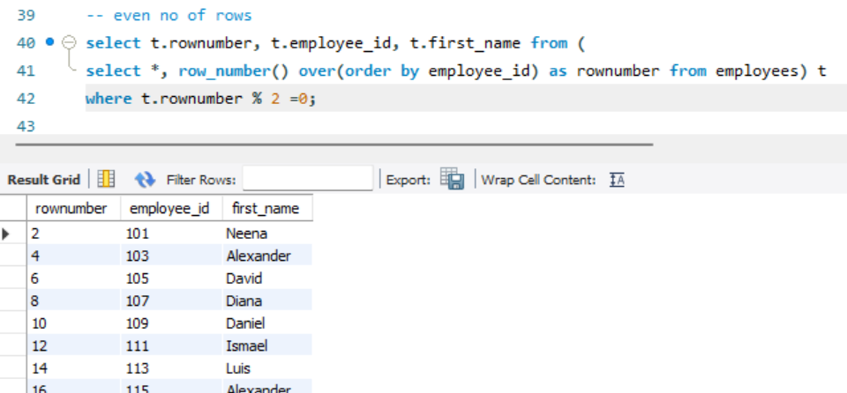

4. How can you remove duplicates from a table(distinct and other way)

1. Using distinct

**select distinct first_name from employees;**

1. Using group by

**SELECT first_name, COUNT(*) AS CNT FROM employees**

**GROUP BY first_name HAVING CNT > 1;**

5. How you can find 5th max salary?(Do it by all 3 ways)

1. Using limit

**select first_name, salary from employees order by salary desc limit 4,1;**

**SELECT * FROM employees ORDER BY salary DESC LIMIT 1 OFFSET 4;**

1. Using dense_rank()

**select * from (select dense_rank() over(order by salary desc) as ranks, first_name,salary from employees) abc where ranks=5;**

-CTE

**with T as (**

**select dense_rank() over(order by salary desc) as ranks, first_name,salary from employees**

**)**

**select * from T where ranks=5;**

1. Using count()

**SELECT first_name, salary FROM employees AS emp1**

**WHERE 5-1 = (SELECT COUNT(DISTINCT salary) FROM employees AS emp2**

**WHERE emp2.salary > emp1.salary);**